ASSIGNMENT: STATISTICS ACT

FILE: STAT_ACT_katherto.pdf

DATE: 12 February 2016

BY: Kathryn Atherton

katherto

Joshua Hahn

Hahn28

Hannah Mackin Schenck

hmackins

SECTION: 03, 1:30-3:30

TEAM: 45

ELECTRONIC SIGNATURE:

Kathryn Atherton

Joshua Hahn

Hannah Mackin Schenck

The electronic signatures above indicate that the document submitted for evaluation is the combined effort of all team members and that each member of the team was an equal participant in its creation. In addition, each member of the team has a general understanding of all aspects of the document.

**TASK 1**

PART A:

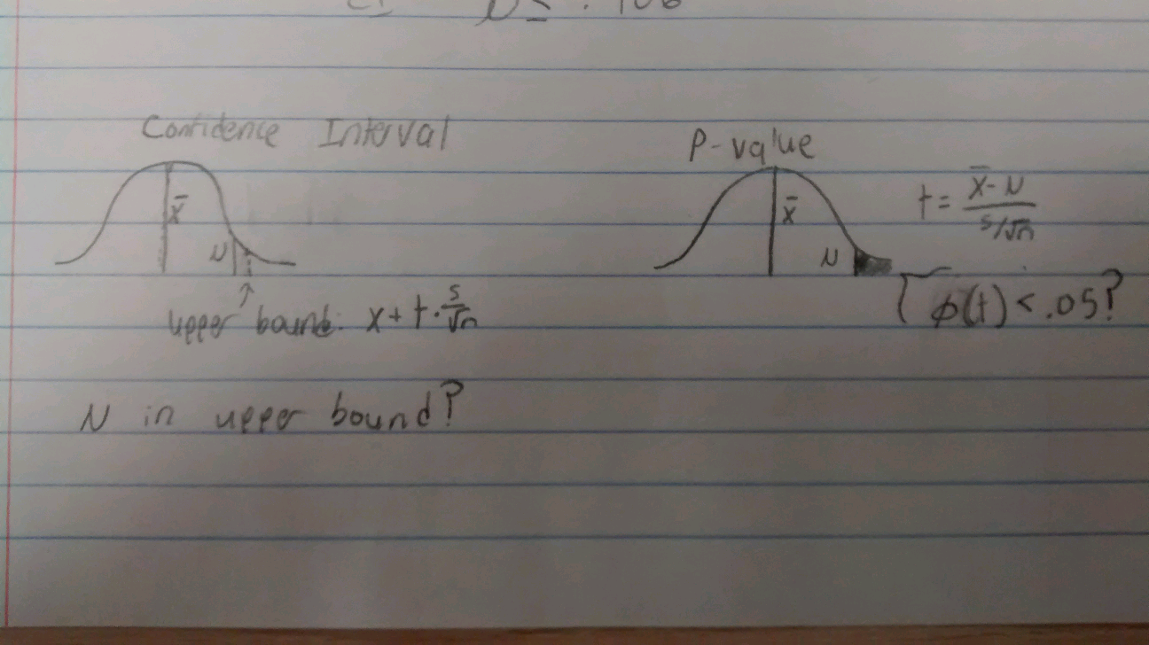

1. **P-VALUE METHOD**

STEP 1: IDENTIFY PARAMETER OF INTEREST: Mean radon concentration

STEP 2: IDENTIFY NULL HYPOTHESIS: Mean radon concentration = 0.40 pCi/L

STEP 3: IDENTIFY ALTERNATIVE HYPOTHESIS: Mean radon concentration < 0.4 pCi/L

STEP 4: IDENTIFY APPROPRIATE TEST STATISTIC: t-test, as we have few samples and it is unclear as to whether or not it is normally distributed

STEP 5: DEFINE CRITERIA FOR REJECTING THE NULL HYPOTHESIS: reject if P-value < 0.05

STEP 6: CALCULATIONS:

* Sample mean: 0.386
* Sample standard deviation: 0.0207
* t = (0.386 – 0.4) / (0.0207 / sqrt(5)) = -1.512
* p is approximately 0.1

STEP 7: STATE CONCLUSIONS: p > 0.05, therefore, we fail to reject the null hypothesis.

1. **CONFIDENCE INTERVALS METHOD**

STEP 1: IDENTIFY PARAMETER OF INTEREST: Mean radon concentration

STEP 2: IDENTIFY NULL HYPOTHESIS: Mean radon concentration = 0.4 pCi/L

STEP 3: IDENTIFY ALTERNATIVE HYPOTHESIS: Mean radon concentration < 0.4 pCi/L

STEP 4: IDENTIFY APPROPRIATE TEST STATISTIC: t-test, as we have few samples and it is unclear as to whether or not it is normally distributed

STEP 5: DEFINE CRITERIA FOR REJECTING THE NULL HYPOTHESIS: reject if 0.4 is not in confidence interval

STEP 6: CALCULATIONS:

* Sample mean = 0.386
* Sample standard deviation = 0.0207
* t = 2.132
* mean = sample mean + (t * (sample standard deviation / sqrt (5)))
* mean <= 0.406

STEP 7: STATE CONCLUSIONS: 0.40 is in confidence interval, therefore, we fail to reject the null hypothesis.

These results validate each other, as both have rejected the null hypothesis.

To get a more conclusive result, one could increase the significance level or the number of data points. Since the upper bound for the confidence level was 0.406, which is very close to 0.40, a few more data points may make the results statistically significant.

**TASK 2:**

PART A

1. Null hypothesis: Mean number of products with defects = 50. Alternative hypothesis: Mean number of products with defects > 50.
2. Null hypothesis: Mean number of products with defects = 50. Alternative hypothesis: Mean number of products with defects != 50.
3. Null hypothesis: Mean number of products with defects = 50. Alternative hypothesis: Mean number of products with defects < 50.
4. Null hypothesis: Mean number of products with defects = 25. Alternative hypothesis: Mean number of products with defects < 25.
5. Null hypothesis: Mean number of products with defects = 25. Alternative hypothesis: Mean number of products with defects > 25.
6. Null hypothesis: The difference between the mean number of products with defects of the two assembly lines = 0. Alternative hypothesis: The difference between the mean number of products with defects of the two assembly lines != 0.
7. Null hypothesis: The difference between the mean number of products with defects of the two assembly lines = 0. Alternative hypothesis: The difference between the mean number of product defects of line one and line two is (mean 1 – mean 2) > 0.
8. Null hypothesis: Mean number of products with defects = 10. Alternative hypothesis: Mean number of products with defects > 10.
9. Null hypothesis: Mean number of products with defects = 10. Alternative hypothesis: Mean number of products with defects < 10.

**TASK 3:**

PART A:



STEP 1: IDENTIFY PARAMETER OF INTEREST: Mean test score

STEP 2: IDENTIFY NULL HYPOTHESIS: Mean test score = 60%

STEP 3: IDENTIFY ALTERNATIVE HYPOTHESIS: Mean test score < 60%

STEP 4: IDENTIFY APPROPRIATE TEST STATISTIC: z-test statistic, as the scores are normally distributed

STEP 5: DEFINE CRITERIA FOR REJECTING THE NULL HYPOTHESIS: reject if p < 0.05

STEP 6: CALCULATIONS:

* Sample mean: 49.5%
* Sample standard deviation: 16.84
* z = (49.5 – 60) / (16.84/ sqrt(32)) = 3.527
* p = 0.5 - .4998 = 0.0002

STEP 7: STATE CONCLUSIONS: p < significance value: reject the null hypothesis.

PART B:

1. 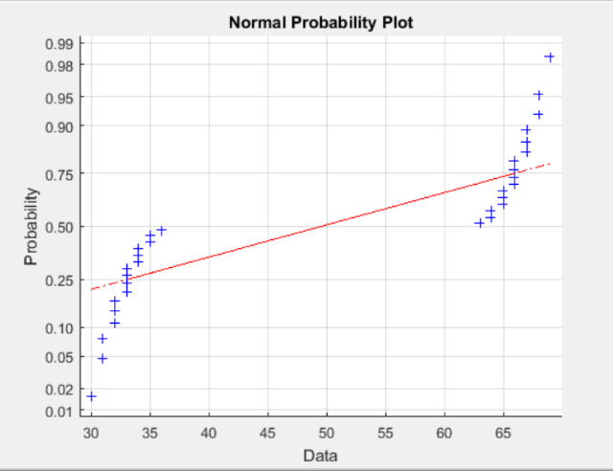
2. Sit outside and ask people to take a test in return for a cookie. Take from various sections/schools/states, etc.

Cheating, a person taking the test more than once.

1. Graph the data using normplot() in MATLAB.
2. Yes, you can use a t-test.

**TASK 4:**

PART A:

STEP 1: IDENTIFY PARAMETER OF INTEREST: Difference in mean de-icing time

STEP 2: IDENTIFY NULL HYPOTHESIS: Difference in mean de-icing time = 0 minutes

STEP 3: IDENTIFY ALTERNATIVE HYPOTHESIS: The mean de-icing time of H1 – the mean de-icing time of H2 > 0 minutes

STEP 4: IDENTIFY APPROPRIATE TEST STATISTIC: z-test, as it is known to be normally distributed

STEP 5: DEFINE CRITERIA FOR REJECTING THE NULL HYPOTHESIS: reject if P-value < 0.05

STEP 6: CALCULATIONS:

* Sample 1 mean: 7
* Sample 2 mean: 5.87
* Sample 1 standard deviation: 1.46
* Sample 2 standard deviation: 1.09
* N1 = 10
* N2 = 4
* Z = 0.4429
* P = 0.5 – 0.4429 = 0.0571

STEP 7: STATE CONCLUSIONS: p > 0.05, therefore, we fail to reject the null hypothesis.

STEP 1: IDENTIFY PARAMETER OF INTEREST: Difference in mean de-icing time

STEP 2: IDENTIFY NULL HYPOTHESIS: Difference in mean de-icing time = 0 minutes

STEP 3: IDENTIFY ALTERNATIVE HYPOTHESIS: The mean de-icing time of H1 – the mean de-icing time of H2 > 0 minutes

STEP 4: IDENTIFY APPROPRIATE TEST STATISTIC: z-test, as it is known to be normally distributed STEP 5: DEFINE CRITERIA FOR REJECTING THE NULL HYPOTHESIS: reject if 0 is not in confidence interval

STEP 6: CALCULATIONS:

* Sample 1 mean: 7
* Sample 2 mean: 5.87
* Sample 1 standard deviation: 1.46
* Sample 2 standard deviation: 1.09
* N1 = 10
* N2 = 4
* Z = 1.645
* Mu = x + z * sqrt(sigma1^2 / n1 + sigma2^2 / n2)
* Mu 1 – Mu2 = -0.45, which is less than 0

STEP 7: STATE CONCLUSIONS: 0 is in confidence interval, therefore, we fail to reject the null hypothesis.

PART B:

1. We committed a Type II error.
2. To prevent making a similar error in future testing, one might increase the significance level, or the number of samples. Increasing samples is expensive. Increasing significance level increases the probability of making a Type I error.

PART C:

1. The conclusion reached may not be valid, if the data is not normally distributed.

**TASK 5:**

PART A:

* Life-threatening-ness of conclusion
  + Inverse relationship with alpha – the more life-threatening the conclusion may be, the higher the significance must be; lower alpha
* Cost per sample
  + Inverse relationship with alpha – the more expensive testing is, the weaker alpha can be
* Availability of samples
  + Direct relationship with alpha – the less samples, the less powerful the results can be
* Standards of practice
  + Higher standard = higher significance level = lower alpha
* Stage of design process
  + The earlier in the process, the less significance is required

PART B:

1. Alpha = 0.01 – the breaking strength of a seatbelt in an airplane is not extremely life threatening, but the seatbelts are probably easy and cheap to test.
2. Alpha = 0.005—this strength is extremely important, but is very expensive to test. However, since life is over money in our rules of thumb, the alpha is closer to the strong end of the spectrum than the above situation.
3. Alpha = 0.05—this value is not very important, but it is very easy/cheap to test.
4. Alpha = 0.01 – the factory produces a high volume of screws, testing is cheap, and the result is important to the company
5. Alpha = 0.1 – this value is not very important, as the design is a prototype, and it may be expensive to test